THROMBOSIS AS A COMPLICATION OF TRANSAPICAL TRANSCATHETER MITRAL VALVE-IN-VALVE IMPLANTATION
R. Shah, D. Hill, A. Waldman, D. Bourque
Orlando Health, Orlando, FL, USA

Background: Transcatheter heart valve (THV) thrombosis remains a challenging complication of transcatheter valve-in-valve (TVIV) implantation. THV thrombosis of the Mitral Valve (MV) can present with marginal changes in transmitral pressure gradients, resulting in missed or delayed diagnoses.
Case: A 61-year-old male with a past medical history of coronary artery disease status-post triple-bypass surgery, bioprosthetic MV replacement and congestive heart failure (CHF) presented with progressive shortness of breath over 2 weeks. Transesophageal Echocardiogram (TEE) showed severe bioprosthetic MV stenosis. Patient underwent transapical transcatheter mitral valve-in-valve implantation and was discharged home with dual anti-platelet therapy. Patient returned to the hospital 8 weeks post-operatively due to worsening shortness of breath. Patient was found to have new onset atrial fibrillation, left atrial appendage thrombus and thrombosis of the mitral valve-in-valve bioprosthesis. Due to this and worsening mitral valve function, patient was started on anticoagulation. A repeat TEE 6 weeks later showed complete resolution of the LAA thrombus and THV thrombosis.

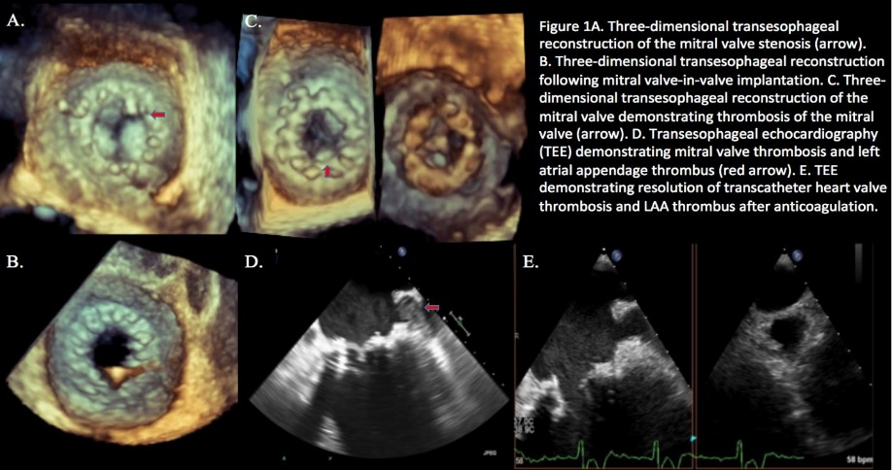
Discussion: Reoperative mitral valve replacements are associated with high operative risk and mortality, particularly in elderly patients with multiple comorbidities. Less invasive techniques, such as a transcatheter modality, has emerged as a viable alternative for patients with degenerated bioprosthetic mitral valves.

